## Sound Detector

The next module we are working with is the sound detector. The wiring job is shown below. If you want to alter the modules sensitivity to noise, simply turn the screw on the top of it.

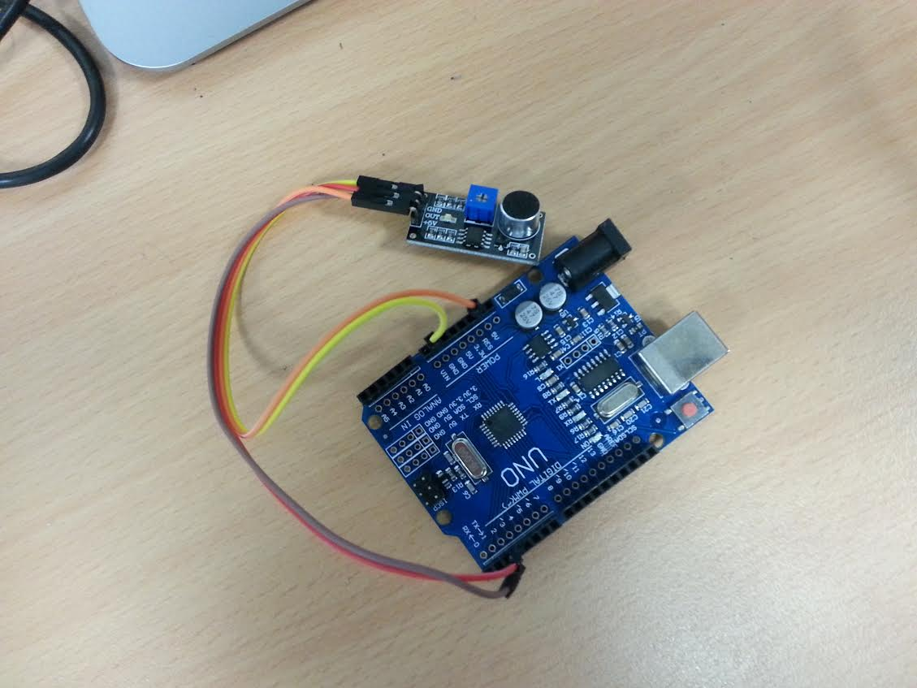

I have connected the +5V pin on the module to the 5v Arduino pin, the GND to the Arduino GND and the out pin on the module to the digital 3 pin on the Arduino. Essentially this module drops the output pin LOW when noise is detected. Below we have an example program which counts the number of noises made and prints it to the serial monitor. No new programming concepts are present, read through the code to understand the tutorial.

int inputPin = 3; //connect the output on the sensor to pin 3, gnd to gnd and vc5v to 5v

int noiseCount = 0;

void setup() {

Serial.begin(9600); //we will write when we hear noise

pinMode(inputPin, INPUT); //setup the pin

}

void loop() {

int hasNoise = !digitalRead(inputPin); //read pin value

if(hasNoise){ //if there is noise, alert

Serial.println(String("noise made, count: ") + String(noiseCount)); //count number of noises

noiseCount++;

delay(1000);

}

delay(10);

}